You used to call me on my cell phone, late night when you need my [PCT wins]. Welcome to the [Customer Experience PCT](https://gus.lightning.force.com/one/one.app#/sObject/0F9B000000008GEKAY/view) newsletter for September, H2 FY18!

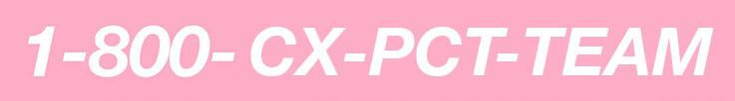

**REFOCUS**

*Kaiju x Refocus Collab Fall 2017*

Our [Refocus](https://gus.lightning.force.com/one/one.app#/sObject/0F9B00000000b7cKAA/view) team has accomplished almost triple the number of wins from last month! The team proposed a feature that would send synthetic metrics from Kaiju to Refocus to essentially bypass the trifecta of Funnel/Kafka/Argus and better troubleshoot for any potential points of failure. Ashish Patel, Senior Software Engineer on Infrastructure Engineering, directed the effort with the Kaiju team to develop and write the code for the DVA Services dashboard. The Refocus team then took the lead to create a rollout plan and implemented this service - care for a visual of said dashboard below? Feel free to send them your compliments and praise.

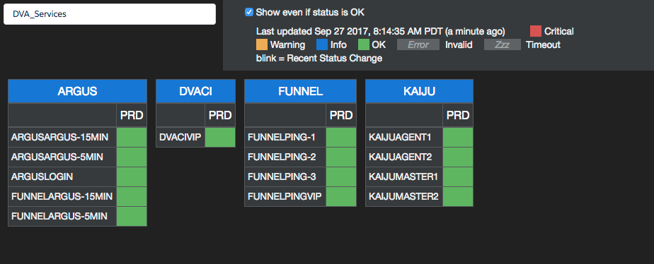

Not only does Refocus provide a quick view of the status for important monitoring tools, but it also provides troubleshooting links to Argus Dashboards and Splunk Logs. This initiative was proposed in the last Hack Day by Pallavi Singh, the Kaiju Team, and Charlie Meynet, to boost reliability and visibility for all DVA Service monitoring. Teamwork truly makes the dream work.



* [Ashish Patel](https://gus.lightning.force.com/one/one.app#/sObject/005B0000000hFcwIAE/view), SMTS
* [Pallavi Singh](https://gus.lightning.force.com/one/one.app#/sObject/005B0000001oUixIAE/view), Software Engineer
* [Charlie Meynet](https://gus.lightning.force.com/one/one.app#/sObject/005B0000000hV0NIAU/view), Project Manager

Want to learn more about this handy platform innovation? Read [here](https://gus.lightning.force.com/one/one.app#eyJjb21wb25lbnREZWYiOiJmb3JjZUNoYXR0ZXI6ZGVza3RvcENoYXR0ZXIiLCJhdHRyaWJ1dGVzIjp7ImZlZWRFbGVtZW50SWQiOiIwRDVCMDAwMDAwVjhsRkwifX0%3D).

*Refocused Thoughts*

The Refocus team sat down with [Peter Doan](https://gus.lightning.force.com/one/one.app#/sObject/005B0000000Gw4fIAC/view), Senior Software Engineer on the DB Pod Build team, to discuss “the Refocus Effect.” More teams are starting to deploy Refocus for service monitoring including the Database Space Reclamation and Database Pod Build team and the business impact is night-and-day. To quote Doan, “we live and die on Refocus, now.” We’ve heard similar talk about adjusting to new platforms before, haven’t we?

Similar to the switch to Lightning, we wish for more teams to integrate Refocus into their processes. #wethebest



* [Iain Usiri](https://gus.lightning.force.com/one/one.app#/sObject/005B0000000Sn9eIAC/view), Product Management Specialist
* [Peter Doan](https://gus.lightning.force.com/one/one.app#/sObject/005B0000000Gw4fIAC/view), SMTS

Will Refocus be your team’s #majorkey to success? Read [here](https://gus.lightning.force.com/one/one.app#/sObject/0D5B000000V7zYZKAZ/view) to find out.

**SITE SWITCHING**

*Site Switching Weekend 2017*

The third weekend of September was most certainly an auspicious one given the sheer number of site switches conducted: a record of twelve! *Prost* from the folks in Munich who celebrated the start of Oktoberfest and the kickoff of the [Site Switch Core Application Protection (SSCAP)](https://gus.lightning.force.com/one/one.app#/sObject/0F9B00000002djsKAA/view) project. The Core Service Protection & Site Switching teams envision that this initiative will bring us one step closer to the esteemed “ubiquitous five-minute site switching!” Let’s give it a shot.



* [Oliver Gruskovnjak](https://gus.lightning.force.com/one/one.app#/sObject/005B0000001r3ZBIAY/view), Lead Product Security Engineer

Want to read into the SSCAP Project? Click [here](https://gus.lightning.force.com/one/one.app#/sObject/0D5B000000UyTpWKAV/view) for more.

*[Hunger] Game[s] Day Success*

The CX team successfully commissioned a planned site switch success on September 16 which took exactly thirty minutes. With careful execution and diligent preparation on behalf of the [Help & Training](https://gus.lightning.force.com/one/one.app#/sObject/0F9B000000000bvKAA/view), [Licensing & Provisioning](https://gus.lightning.force.com/one/one.app#/sObject/0F9B0000000007qKAA/view), and Org62 organizations, NA44’s site switch was completed without an incident or issue!

Shoutout to Robert Lai, a Senior Systems Engineer, for [documenting](https://docs.google.com/document/d/1NkwcZ2MwNzEpARWvxWFHN1nU2hdvnmJC406BB9j-zac/edit) the results of the NA44 switch and resiliency plan for the future. Game Day folks, may the odds ever be in your favor.



* [Robert Lai](https://gus.lightning.force.com/one/one.app#/sObject/005B0000001sroPIAQ/view), Senior Systems Engineer

If you’d like to read more details about the NA44 site switch, click [here](https://gus.lightning.force.com/one/one.app#/sObject/0D5B000000VG63yKAD/view).

*15 Minutes Could Save You…*

Can switching to Geico really save you 15% or more? We’re not experts but apparently SITE switching takes even less time than for you to get car insurance. Take a seat, Geico.

The Site Switching team has been working with Site Reliability to continue improving timing and efficiency in the past months. In the spirit of Lightning, the timing of planned site switches has decreased significantly with the help of Kit Sin and Dilan Udayakumara, both Site Reliability Engineers!

CS60, CS61, and NA38 were switched from PHX to DFW in 10, 11, and 13 minutes respectfully. The impact? Priceless.



* [Kit Sin](https://gus.lightning.force.com/one/one.app#/sObject/005B0000000hKDAIA2/view), Site Reliability Engineer
* [Dilan Udayakumara](https://gus.lightning.force.com/one/one.app#/sObject/005B0000001JKpDIAW/view), Site Reliability Engineer

Interested in reading more about the Site Switching team? Click [here](https://gus.lightning.force.com/one/one.app#/sObject/0D5B000000VA0t2KAD/view).

**INDUSTRY TALKS**

*On Big Data & Talking Code: Jay Robinson*

Jay Robinson, Senior Software Engineer, will be leading this year’s 12th industry talk on **Performance & Scale for SQL Server** at the PASS Summit in Seattle, WA this October! His talk, titled “Better Performance in the SqlClient Namespace [Dev],” addresses the performance of data access code through careful analysis of the SQLClient namespace in the .NET Framework.

Does this sound technical enough for you? Let’s just say that after this session, you’ll be better prepared to create scalable solutions that depend on the SQLClient namespace. Mahalo to you, Jay, for representing Salesforce in the industry and good luck!



* [Jay Robinson](https://gus.lightning.force.com/one/one.app#/sObject/005B00000018dYTIAY/view), Senior Systems Engineer

Want to read more about Jay’s talk session? Click [here](http://www.pass.org/summit/2017/Sessions/Details.aspx?sid=68814) for the session description!

**REFLECTION: OUR OPERATIONAL EXCELLENCE & AUTOMATION METHOD**

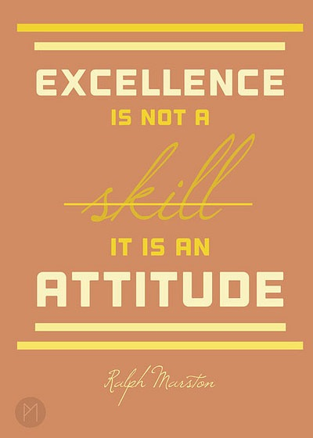

This month, [Garren Bellew](https://gus.lightning.force.com/one/one.app#/sObject/005B0000000goY8IAI/view), Senior Manager of the Global Services Management Team, will shed some light on what embodies operational excellence to the finest - the incident object. The incident object provides more visibility into data that allows for better business judgement and helps us create better decisions as a result.

“Customer Experience, in terms of performance degradation, service disruption, etc., is now available within GUS and its impact can be analyzed in terms of overall service ability.

Up until September of this year, actual customer experience was presented via our home for real-time system performance and performance - Trust. However, this essential data was not actually captured anywhere within GUS.

The Global Services Management Team, in collaboration with the Dublin Tier 3 Developer Support Team, has built a native Lightning App called TRUST2GUS which leverages the Trust API and automatically synchronises Trust post information into a GUS Incident record.

The team also built a Google Chrome extension which leverages a Java Server Page to retrieve live RacNode information from an affected pod, and this data is also harmonised within GUS.

Our longer reaching goal is to to be able to offer an ‘On-Demand Service Availability Analysis’ facility to everyone and these new enhancements have brought that goal a lot closer.”



Can we elaborate any more? Read into this [post](https://gus.lightning.force.com/one/one.app#/sObject/0D5B000000VC6RXKA1/view) about how automation leads to more accurate incident information. ***#winning***

**That's it for this month, folks.** Thanks for tuning into this month's “CX Bling” Newsletter! Want to propose a PCT win for a feature on next month's issue? Submit it [here](https://gus.lightning.force.com/one/one.app#/sObject/0TOB00000009rivOAA/view).